# import librariesimport boto3, re, sys, math, json, os, sagemaker, urllib.requestfrom sagemaker import get_execution_roleimport numpy as npimport pandas as pdimport matplotlib.pyplot as pltfrom IPython.display import Imagefrom IPython.display import display

from time import gmtime, strftime

from sagemaker.predictor import csv_serializer



# Define IAM role

role = get_execution_role()

prefix = 'sagemaker/DEMO-xgboost-dm'

my_region = boto3.session.Session().region_name # set the region of the instance

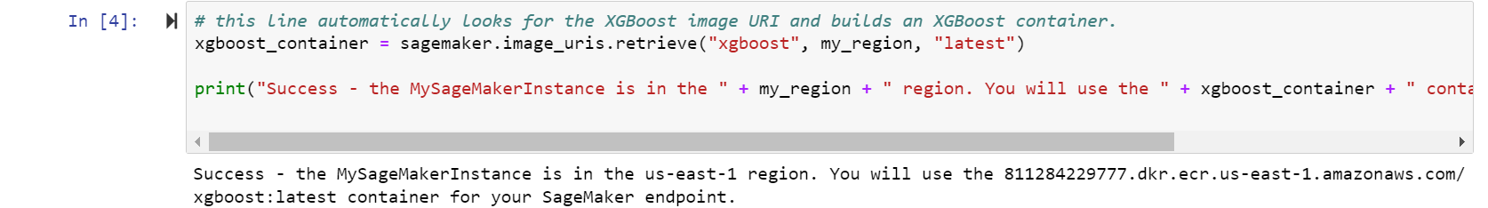

# this line automatically looks for the XGBoost image URI and builds an XGBoost container.xgboost_container = sagemaker.image_uris.retrieve("xgboost", my_region, "latest")print("Success - the MySageMakerInstance is in the " + my_region + " region. You will use the " + xgboost_container + " container for your SageMaker endpoint.")

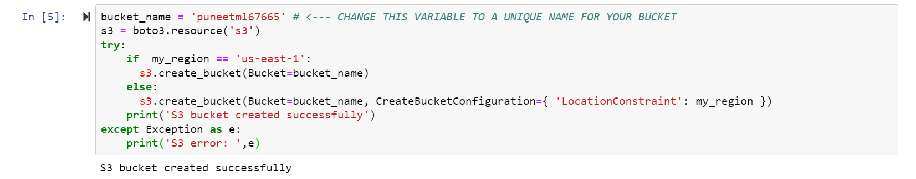

bucket_name = 'puneetml67665' # <--- CHANGE THIS VARIABLE TO A UNIQUE NAME FOR YOUR BUCKET

s3 = boto3.resource('s3')

try:

if my_region == 'us-east-1':

s3.create_bucket(Bucket=bucket_name)

else:

s3.create_bucket(Bucket=bucket_name, CreateBucketConfiguration={ 'LocationConstraint': my_region })

print('S3 bucket created successfully')

except Exception as e:

print('S3 error: ',e)



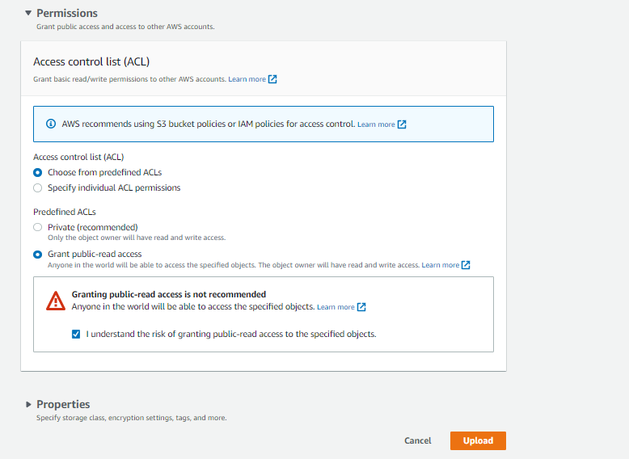

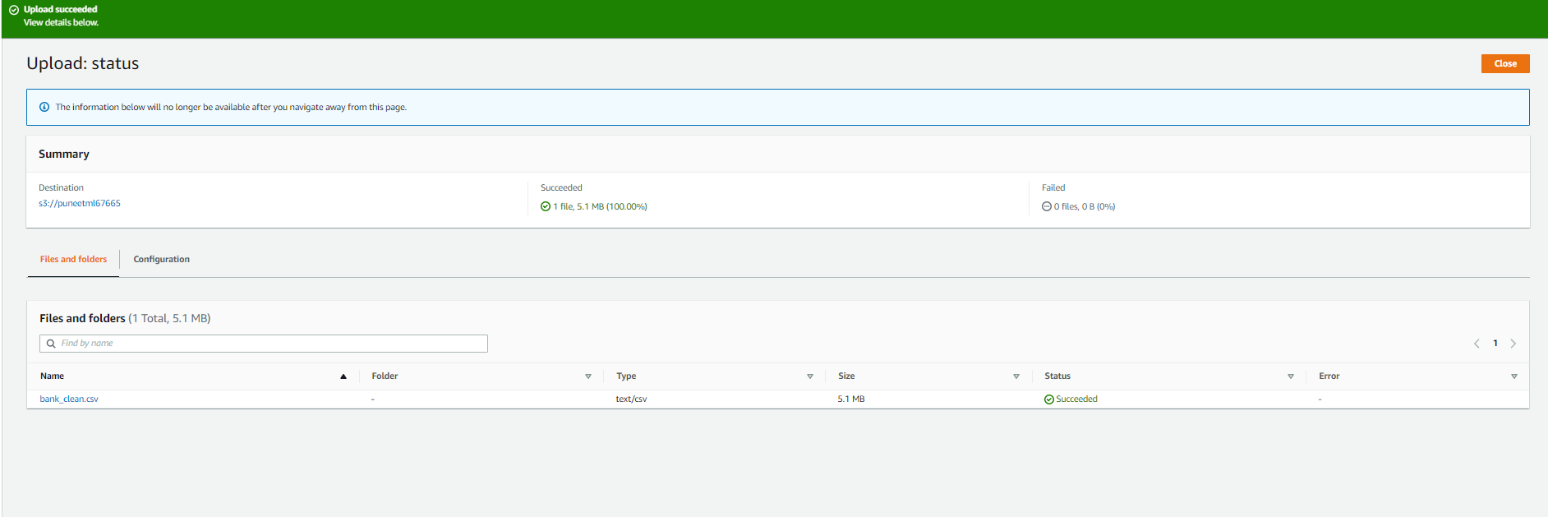

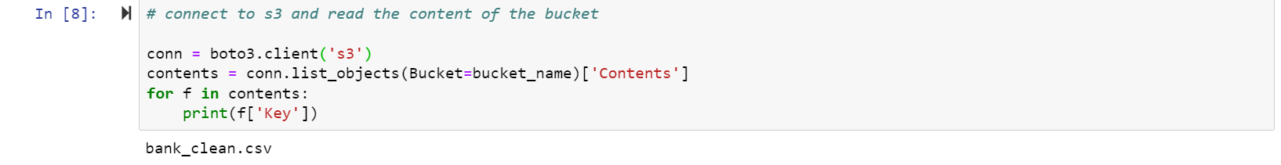

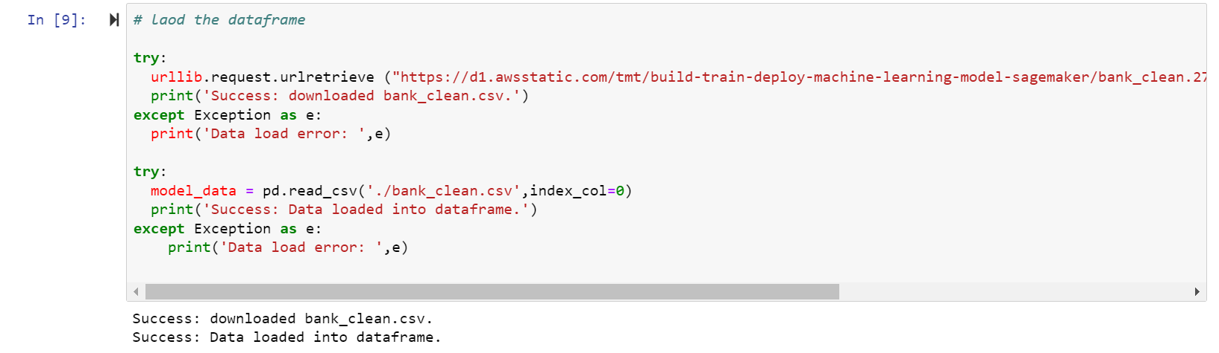

try: urllib.request.urlretrieve ("https://d1.awsstatic.com/tmt/build-train-deploy-machine-learning-model-sagemaker/bank_clean.27f01fbbdf43271788427f3682996ae29ceca05d.csv", "bank_clean.csv") print('Success: downloaded bank_clean.csv.')except Exception as e:

print('Data load error: ',e)

try:

model_data = pd.read_csv('./bank_clean.csv',index_col=0)

print('Success: Data loaded into dataframe.')

except Exception as e:

print('Data load error: ',e)

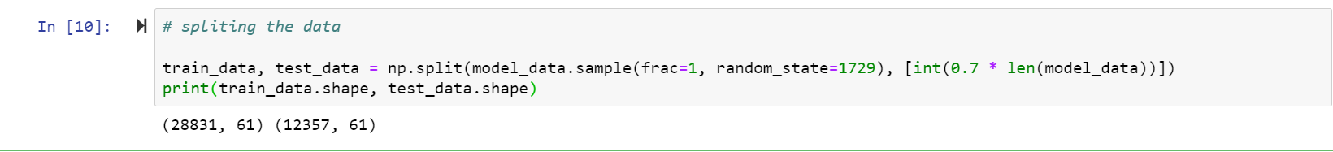

train_data, test_data = np.split(model_data.sample(frac=1, random_state=1729), [int(0.7 * len(model_data))])

print(train_data.shape, test_data.shape)

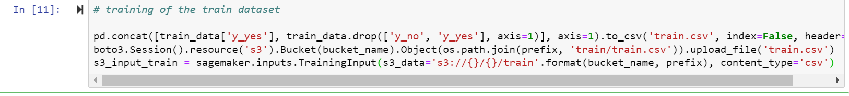

pd.concat([train_data['y_yes'], train_data.drop(['y_no', 'y_yes'], axis=1)], axis=1).to_csv('train.csv', index=False, header=False)boto3.Session().resource('s3').Bucket(bucket_name).Object(os.path.join(prefix, 'train/train.csv')).upload_file('train.csv')

s3_input_train = sagemaker.inputs.TrainingInput(s3_data='s3://{}/{}/train'.format(bucket_name, prefix), content_type='csv')

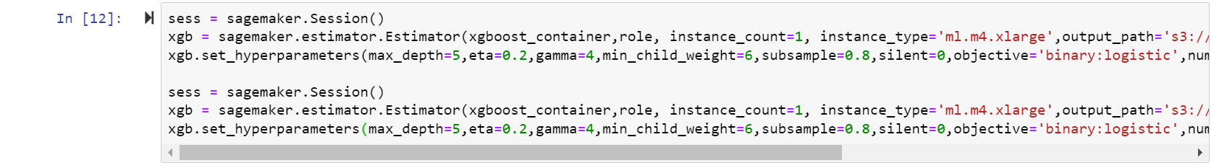

sess = sagemaker.Session()xgb = sagemaker.estimator.Estimator(xgboost_container,role, instance_count=1, instance_type='ml.m4.xlarge',output_path='s3://{}/{}/output'.format(bucket_name, prefix),sagemaker_session=sess)xgb.set_hyperparameters(max_depth=5,eta=0.2,gamma=4,min_child_weight=6,subsample=0.8,silent=0,objective='binary:logistic',num_round=100)sess = sagemaker.Session()xgb = sagemaker.estimator.Estimator(xgboost_container,role, instance_count=1, instance_type='ml.m4.xlarge',output_path='s3://{}/{}/output'.format(bucket_name, prefix),sagemaker_session=sess)

xgb.set_hyperparameters(max_depth=5,eta=0.2,gamma=4,min_child_weight=6,subsample=0.8,silent=0,objective='binary:logistic',num_round=100)



xgb.fit({'train': s3_input_train})

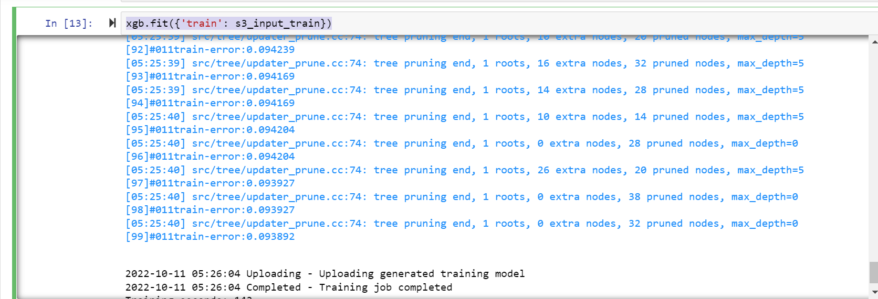

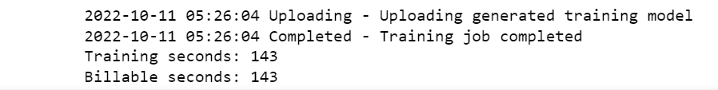



xgb_predictor = xgb.deploy(initial_instance_count=1,instance_type='ml.m4.xlarge')

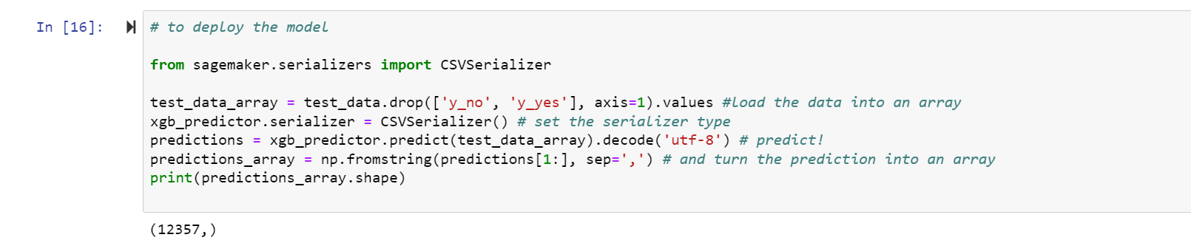

# to deploy the model

from sagemaker.serializers import CSVSerializer

test_data_array = test_data.drop(['y_no', 'y_yes'], axis=1).values #load the data into an array

xgb_predictor.serializer = CSVSerializer() # set the serializer type

predictions = xgb_predictor.predict(test_data_array).decode('utf-8') # predict!

predictions_array = np.fromstring(predictions[1:], sep=',') # and turn the prediction into an array

print(predictions_array.shape)

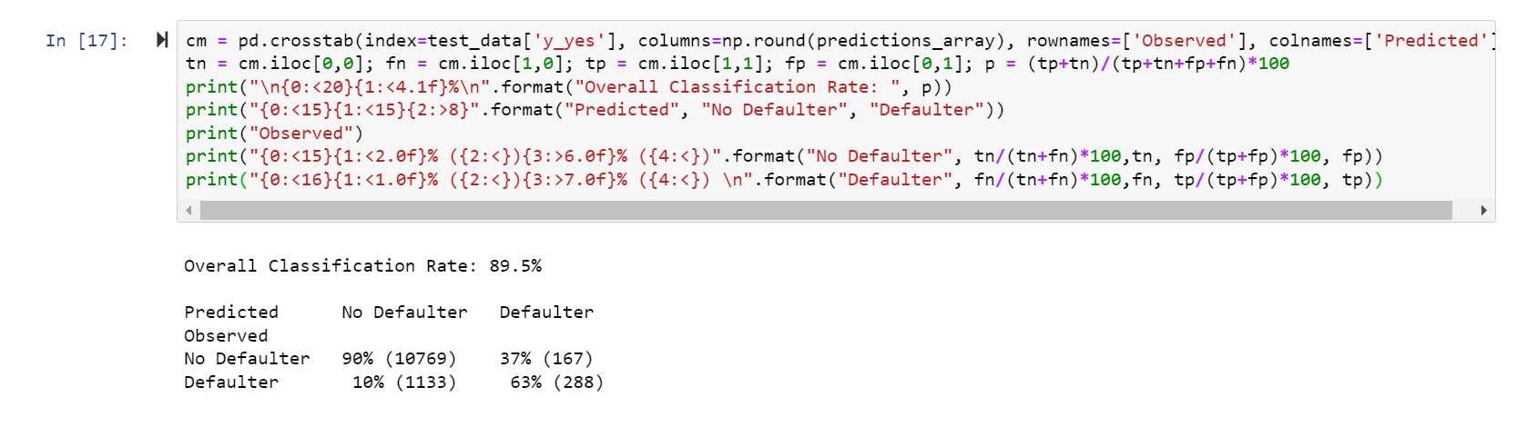

cm = pd.crosstab(index=test_data['y_yes'], columns=np.round(predictions_array), rownames=['Observed'], colnames=['Predicted'])

tn = cm.iloc[0,0]; fn = cm.iloc[1,0]; tp = cm.iloc[1,1]; fp = cm.iloc[0,1]; p = (tp+tn)/(tp+tn+fp+fn)*100

print("\n{0:<20}{1:<4.1f}%\n".format("Overall Classification Rate: ", p))

print("{0:<15}{1:<15}{2:>8}".format("Predicted", "No Defaulter", "Defaulter"))

print("Observed")

print("{0:<15}{1:<2.0f}% ({2:<}){3:>6.0f}% ({4:<})".format("No Defaulter", tn/(tn+fn)*100,tn, fp/(tp+fp)*100, fp))

print("{0:<16}{1:<1.0f}% ({2:<}){3:>7.0f}% ({4:<}) \n".format("Defaulter", fn/(tn+fn)*100,fn, tp/(tp+fp)*100, tp))